# Terms and conditions

The information provided by the Roth Analysis tool is for general informational and educational purposes only. As such, it should not be used as a substitute for consultation with professional accounting, tax, legal or other competent advisers.

This tool and the results it generated is provided in good faith; however, no warranty of any kind, express or implied, regarding the accuracy, adequacy, validity, reliability, availability, completeness, or security of any information surrounding the use of this tool.

Under no circumstance shall we have any liability to you for any loss or damage of any kind arising out of or in connection with the use of the site or reliance on any information provided on the site. Your use of the site and your reliance on any information on the site is solely at your risk.

# About the Roth Conversion Analysis Tool

The Roth Conversion Analysis Tool allows a user to enter financial information about themself and optionally their spouse, and up to five Roth Conversion scenarios. Once done, the user can view and compare projected results for the different Roth Conversion Scenarios. For example,

* Compare their Total assets for each scenario for a given year.
* Compare their resulting Roth assets for each scenario for a given year.
* Compare their resulting Traditional IRA assets for each scenario for a given year.
* Compare their resulting taxable assets for each scenario for a given year.
* Compare their resulting non-TRA assets for each scenario for a given year.
* Compare their resulting yearly taxes for each scenario for a given year.
* Compare their resulting cumulative taxes for each scenario for a given year.

The overall goal would be for the user to use this information to tune / tweak your Roth Conversion scenarios to identify an optimal Roth Conversion strategy their specific goals.

## Why doesn’t the tool just find the users optimal Roth Conversion strategy?

The reader may think this a cop-out but the author simply doesn’t know what the user’s specific optimization goals might be.

* Total available assets at some specific year?
* Minimize Traditional IRA assets?
* Maximize Roth assets?
* Maximize non-IRA assets?
* Minimize Cumulative Taxes?
* Some blend of the above?

There is also the question of what specific year to optimize for? The user may be inclined to choose the same year that they use for their financial plan, yet, perhaps this does not make sense. A financial plan-end-year is often chosen to be the year where the user has a tiny probability to still be living and a high probability that they will have died in an earlier year. For Roth conversions, the user may want to instead focus on an end-year where there is a high probability that they will live until that year but not live beyond. For example, perhaps a good financial play end-year would be the year the user turns 95, but in contrast, the most likely end of life is when the user turns 85. This analysis tool doesn’t know what age to optimize for and likely the user will not either, so instead, the analysis tool provides the ability to visualize/compare results across the entire plan timeline.

## Tool Limitations

**Accuracy**

Every effort has been made to provide accurate results, that said, it must be understood that the tool generates estimations and not exact results. For example,

* Tax rules are only known for a subset of the possible years in the plan, and certainly not for future years. Instead, the tool performs extrapolations (estimates) for tazes for this year based on the closest years tax rules that it does have.
* The most common tax rules are factored into the estimated but it does not consider may more obscure tax rules.
* Garbage in – garbage out. The user chooses a lot of the variables that go into the calculations. The generated results are only as good as these configured variables.

**Married-Filing-Separately NOT Supported**

The federal filing status of married-filing-separately is currently not supported. This required a more complex specification of the Roth Scenarios that was beyond the first too iteration.

# User Interface

## Overview

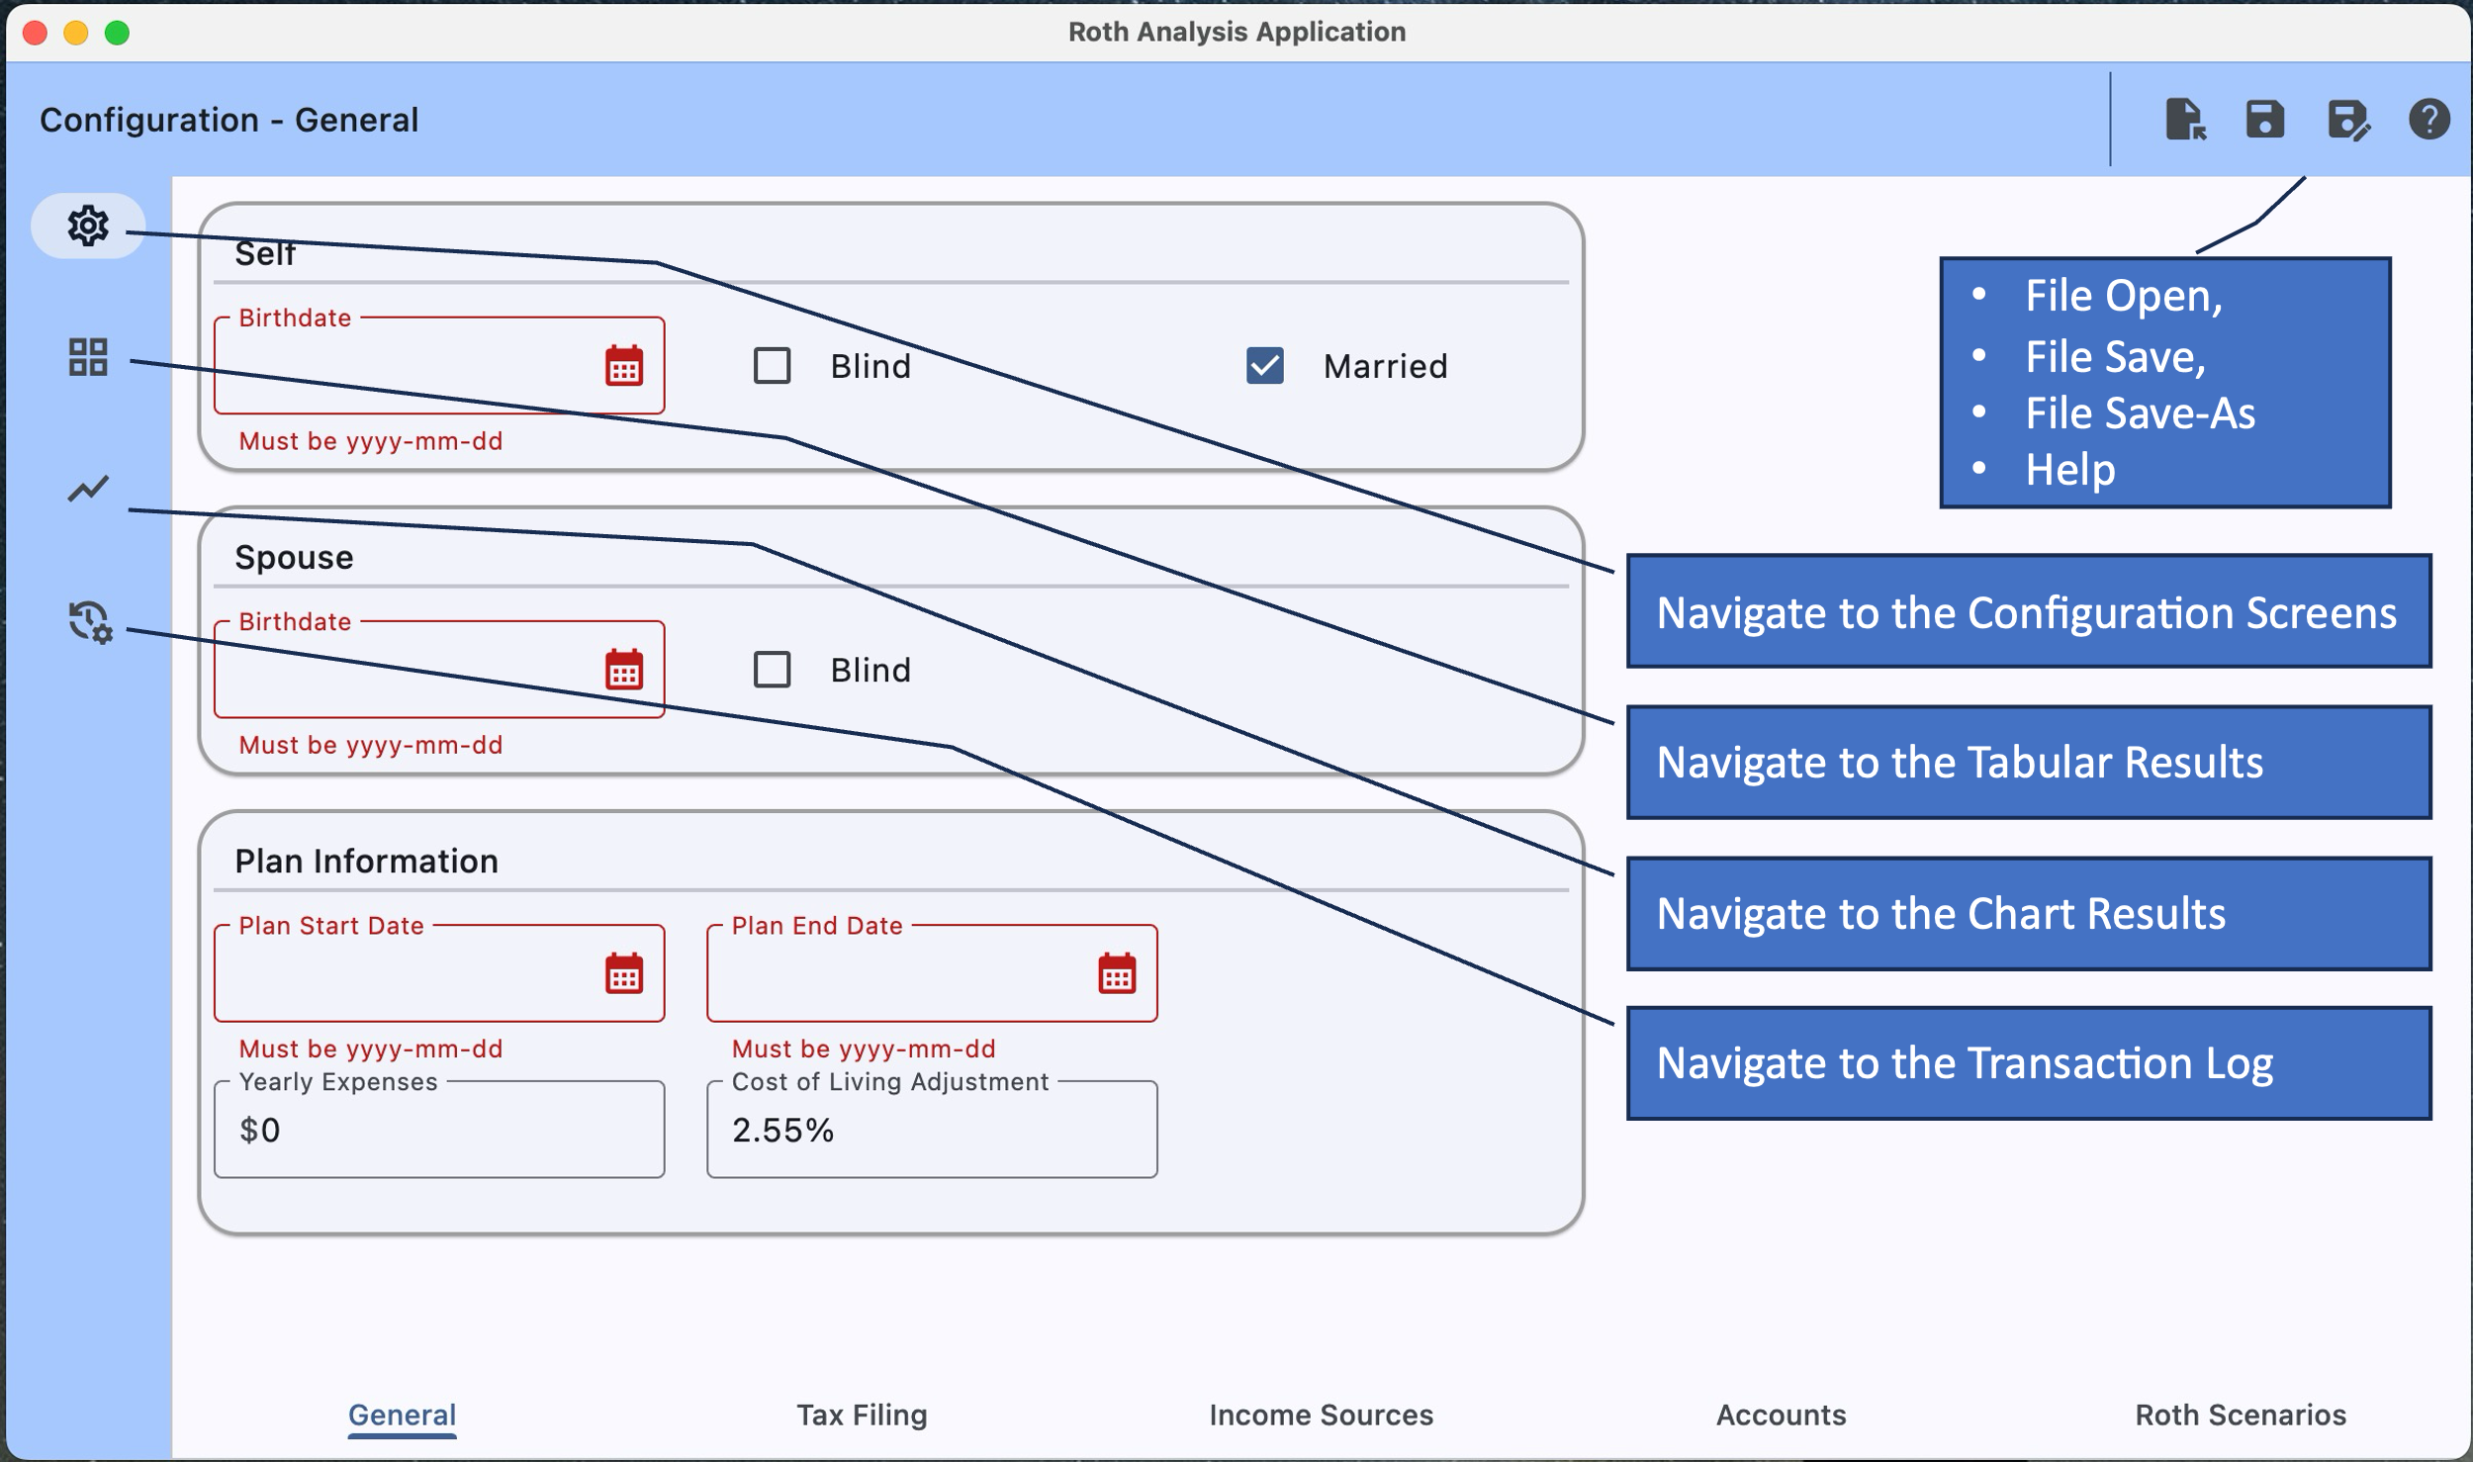

## Configuration Screens

### Configuration - Overview

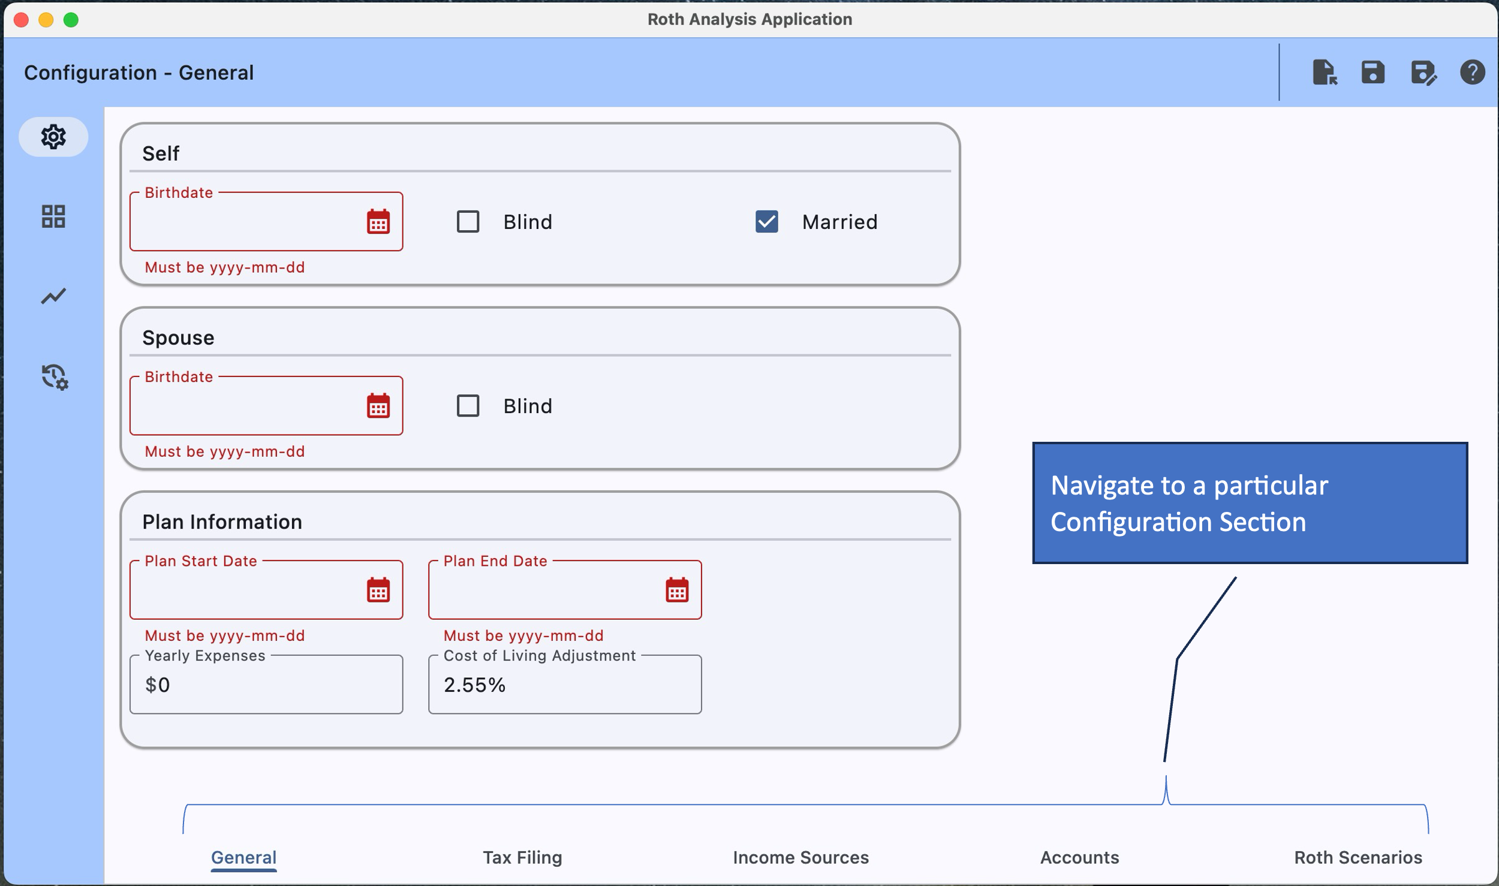

### Configuration - General

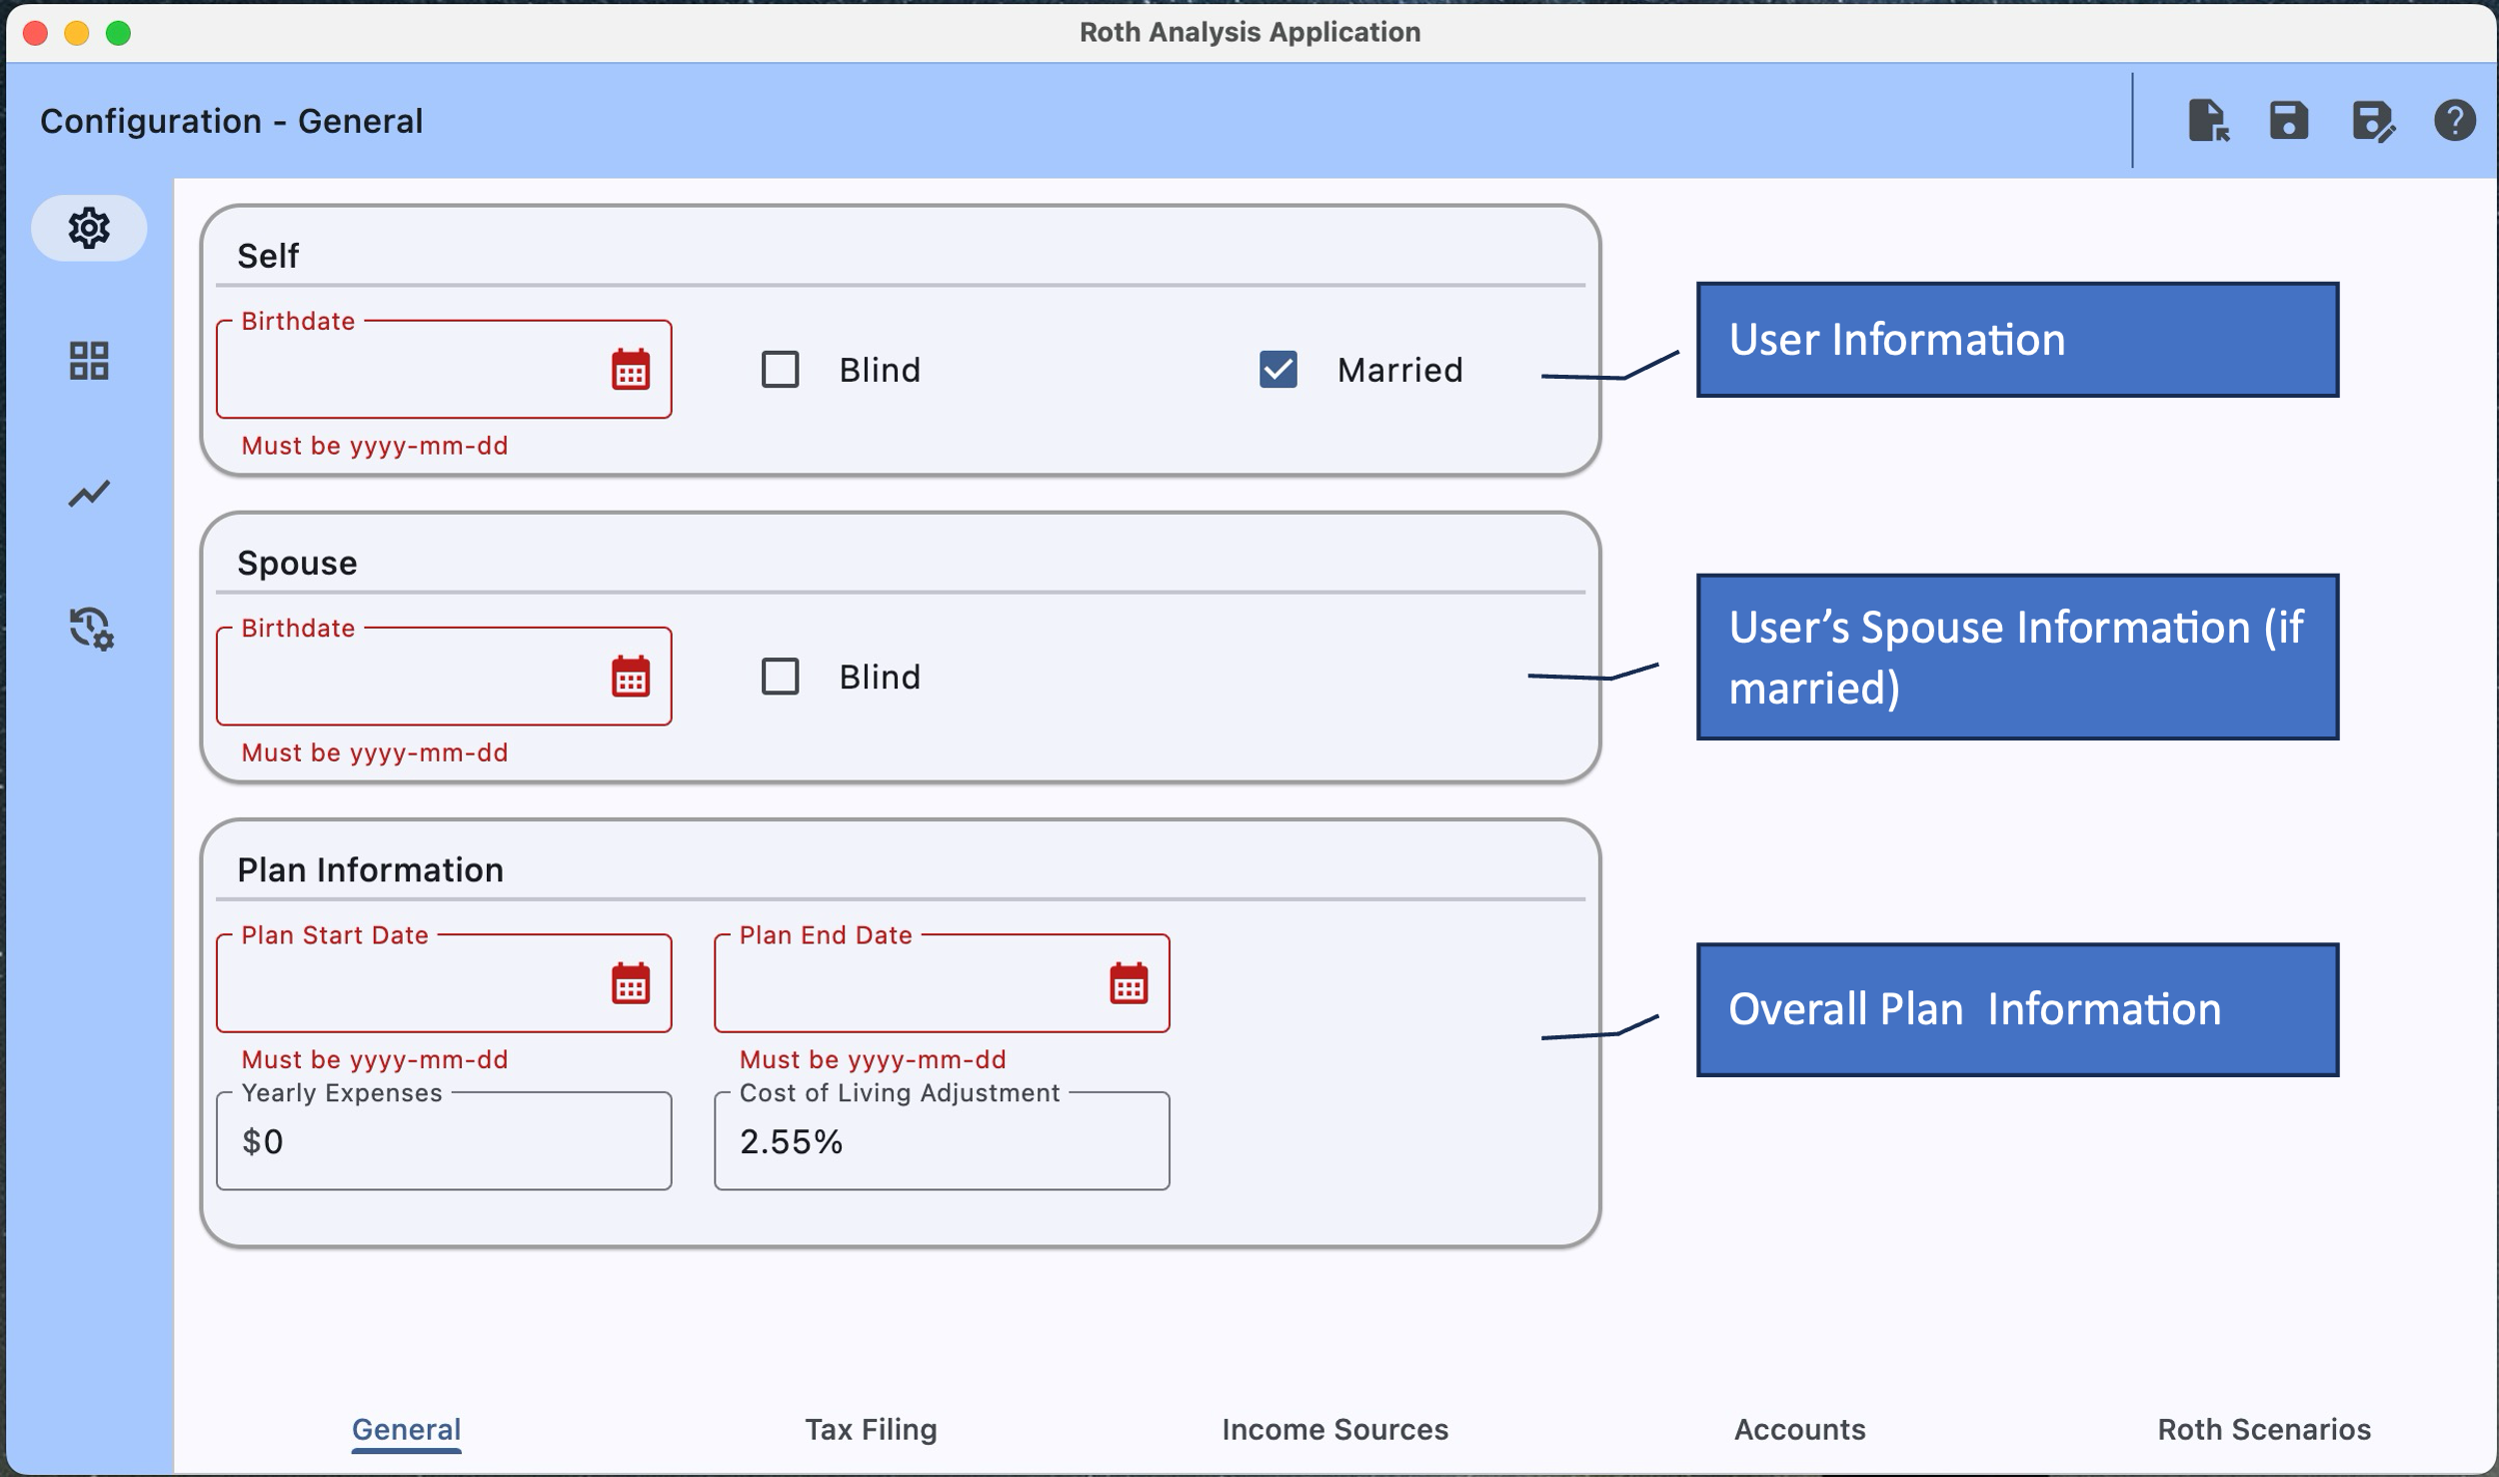

**User (Self/Spouse) Information**

* Self/Spouse Information is mostly self-explanatory.
  + Birthdate – FYI: Only the year and month are relevant in the analysis.
* Plan Information is mostly self-explanatory.
  + Plan Start Date – Generally recommend choosing the first day of the month for the plan start date.
  + Plan End Date – Generally recommend choosing the last day of the month for the plan end date.

**Plan Information**

* Yearly Expenses – estimate of user’s total yearly expenses including any medical expenses.
* Cost of Living Adjustment – percentage used to estimate future looking information such as years expenses, income for a year and to estimate taxes for years where no tax rules exist.

### Configuration - Tax Filing

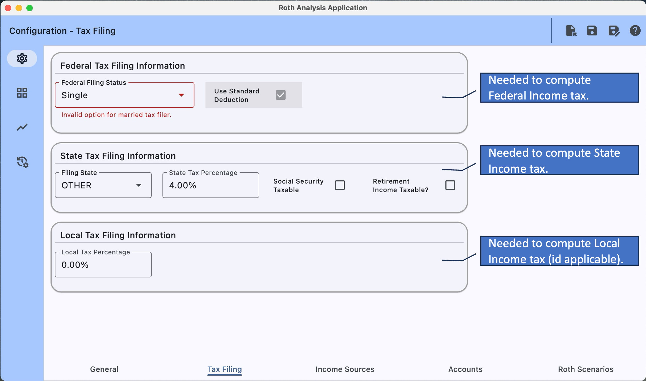

**Federal Tax Filing Information**

|  |  |
| --- | --- |
| Field Name | Field Description |
| Federal Filing Status | Select one of...   * Single * Married Filing Jointly * Married Filing Separately – Currently not supported. * Head of Household |
| Use Standard Deduction | Currently the only supported option. |

**State Tax Filing Information**

|  |  |
| --- | --- |
| Field Name | Field Description |
| Filing State | Currently about a dozen states are supported. If the user’s state is not supported, they must select other and configure the three options below that most closely represent their state. |
| State Taxing Percentage | Choose a value most appropriate for the user’s state.  Note: Only shown for a state of “OTHER”. |
| Social Security Taxable? | Few / some states tax social security as regular income, if the user’s state is one of these states, they should check this option.  Note: Only shown for a state of “OTHER”. |
| Retirement Income Taxable? | Most states tax retirement income such as pensions and Traditional IRA withdraws as regular income but some do not. If the user’s state is one of the states that do not tax retirement income, they should uncheck this option.  Note: Only shown for a state of “OTHER”. |

**Local Tax Filing Information**

|  |  |
| --- | --- |
| Field Name | Field Description |
| Local Tax Percentage | Some local communities/cities require a local income tax to be collected/paid. If the user’s state has a local tax, they must set the local taxing rate / percentage and if not, they must set this to 0.00%. |

### Configuration - Income Sources

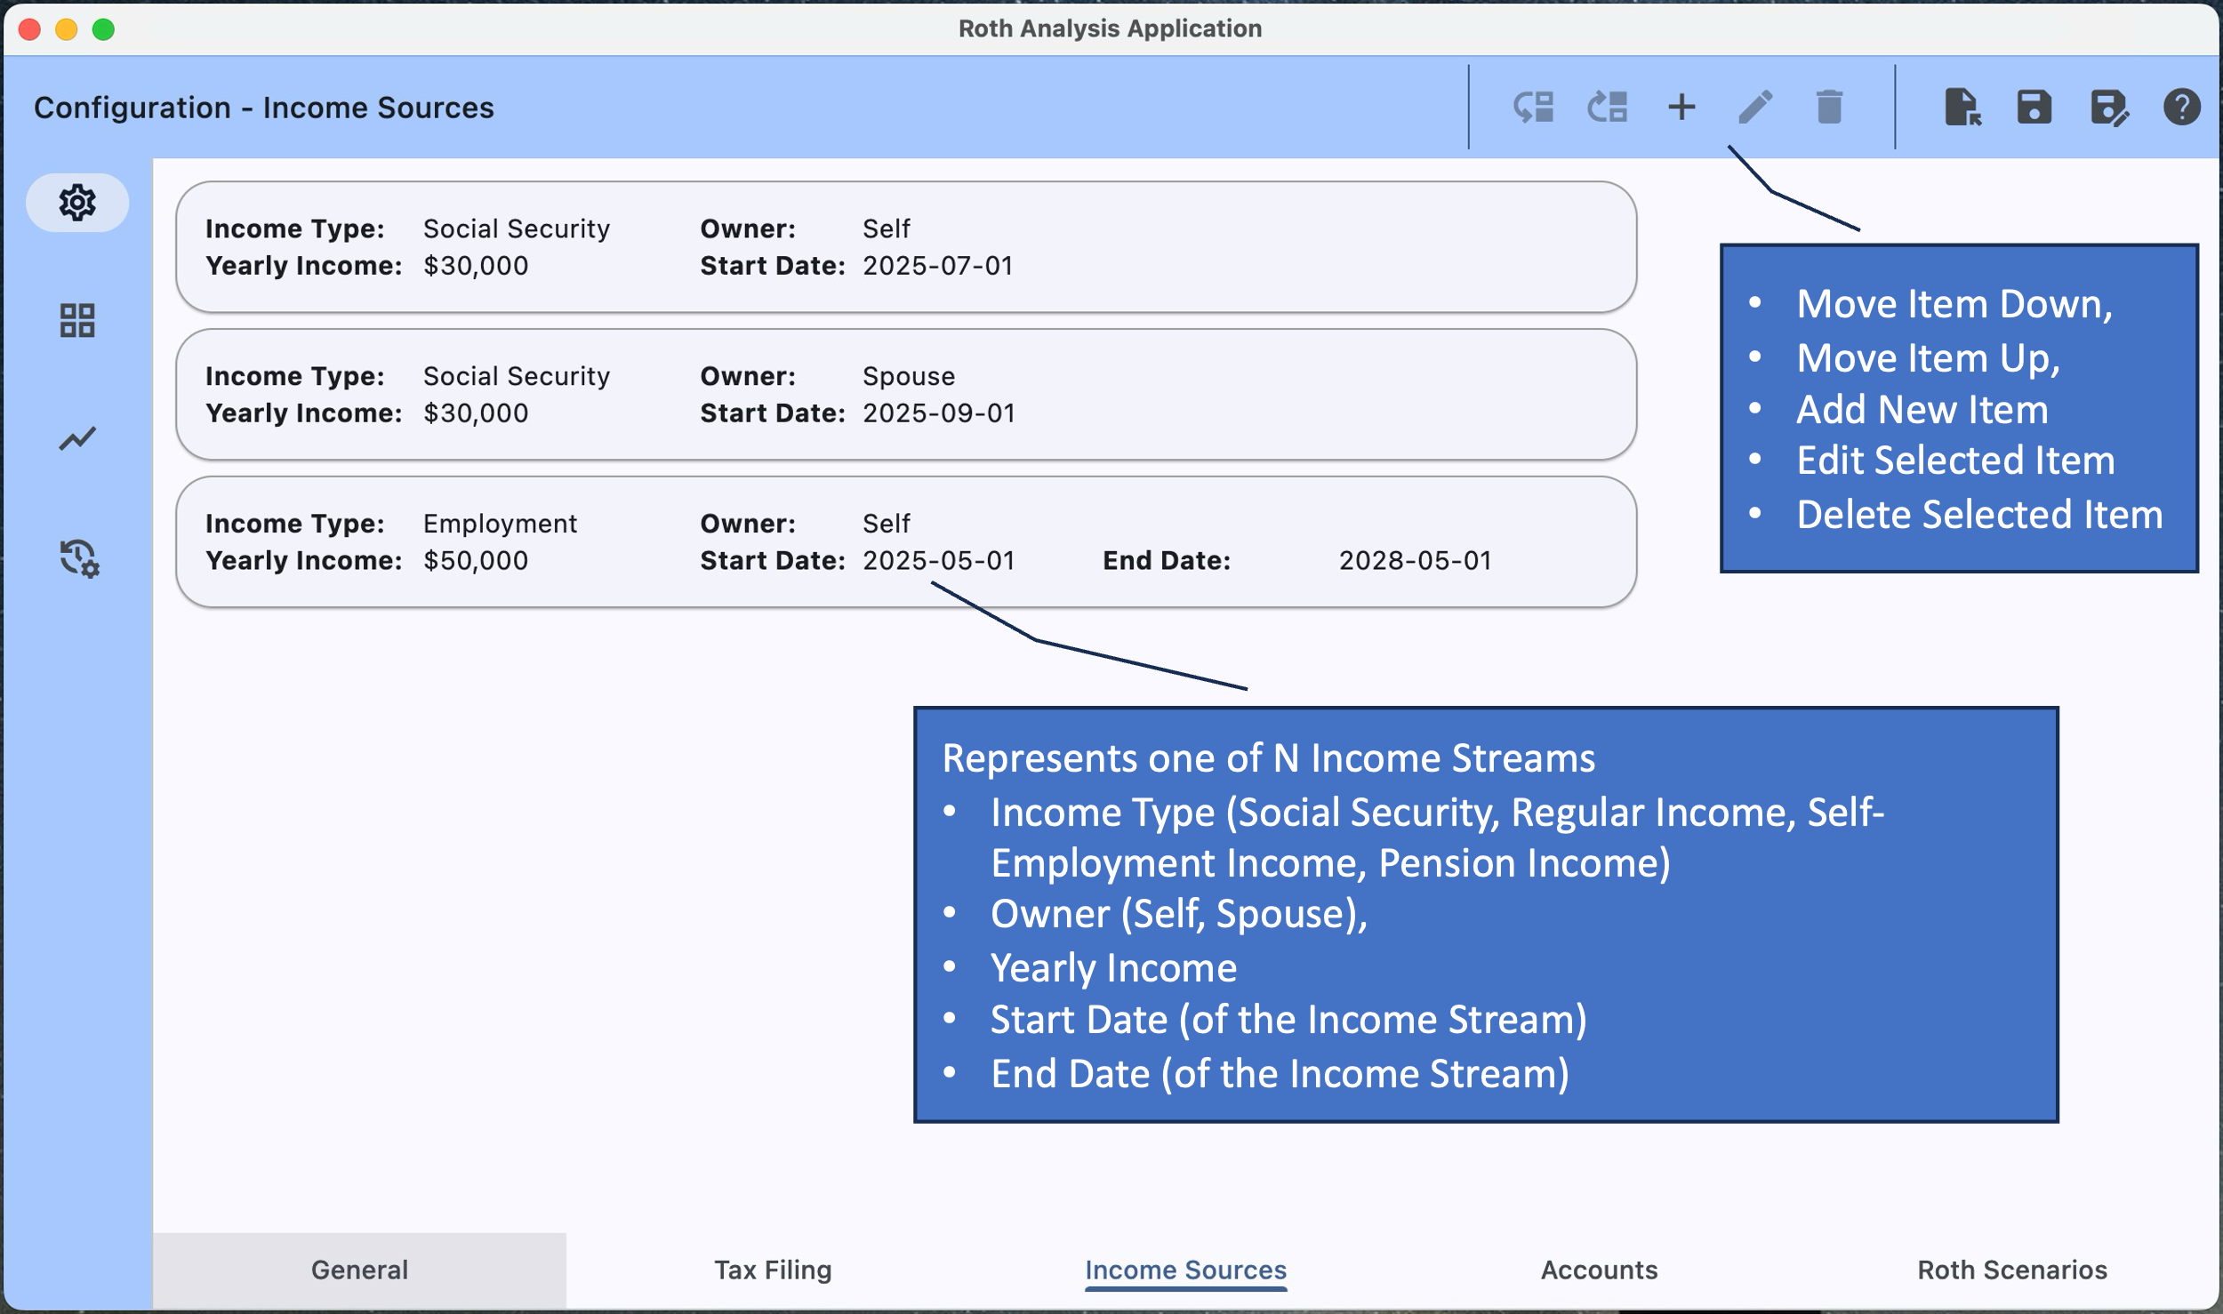

Displays and allows modification to all of the income sources in the plan. Existing items can be moved up, moved down, edited or deleted, i.e., via the buttons on the application bar. Note: That an item can also be edited by double-clicking on it which provides the following edit form…

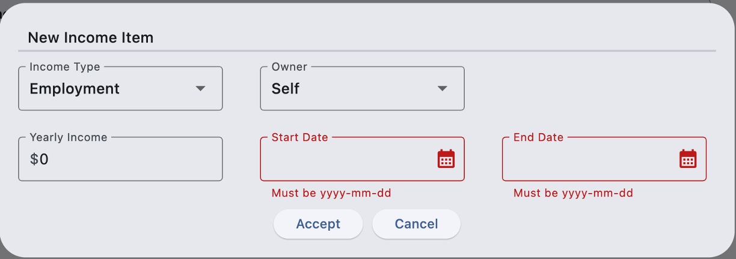

|  |  |
| --- | --- |
| Field Name | Field Description |
| Income Type | Select one of: “Employment”, “Self-Employment”, “Social Security”, or “Pension”. |
| Owner | Select one of: “Self” or “Spouse. |
| Yearly Income | Select expected yearly income for the start year. Note: This value will be inflated by the cost-of-living rate for each subsequent year. |
| Start Date | Select date that the income source will start.  Notes:   * The day of the month is generally ignored. |
| Stop Date | Select date that the income source will stop.  Notes:   * The day of the month is generally ignored. * Social Security end-date is not configurable and is assumed to be on end of plan. |

### Configuration - Accounts

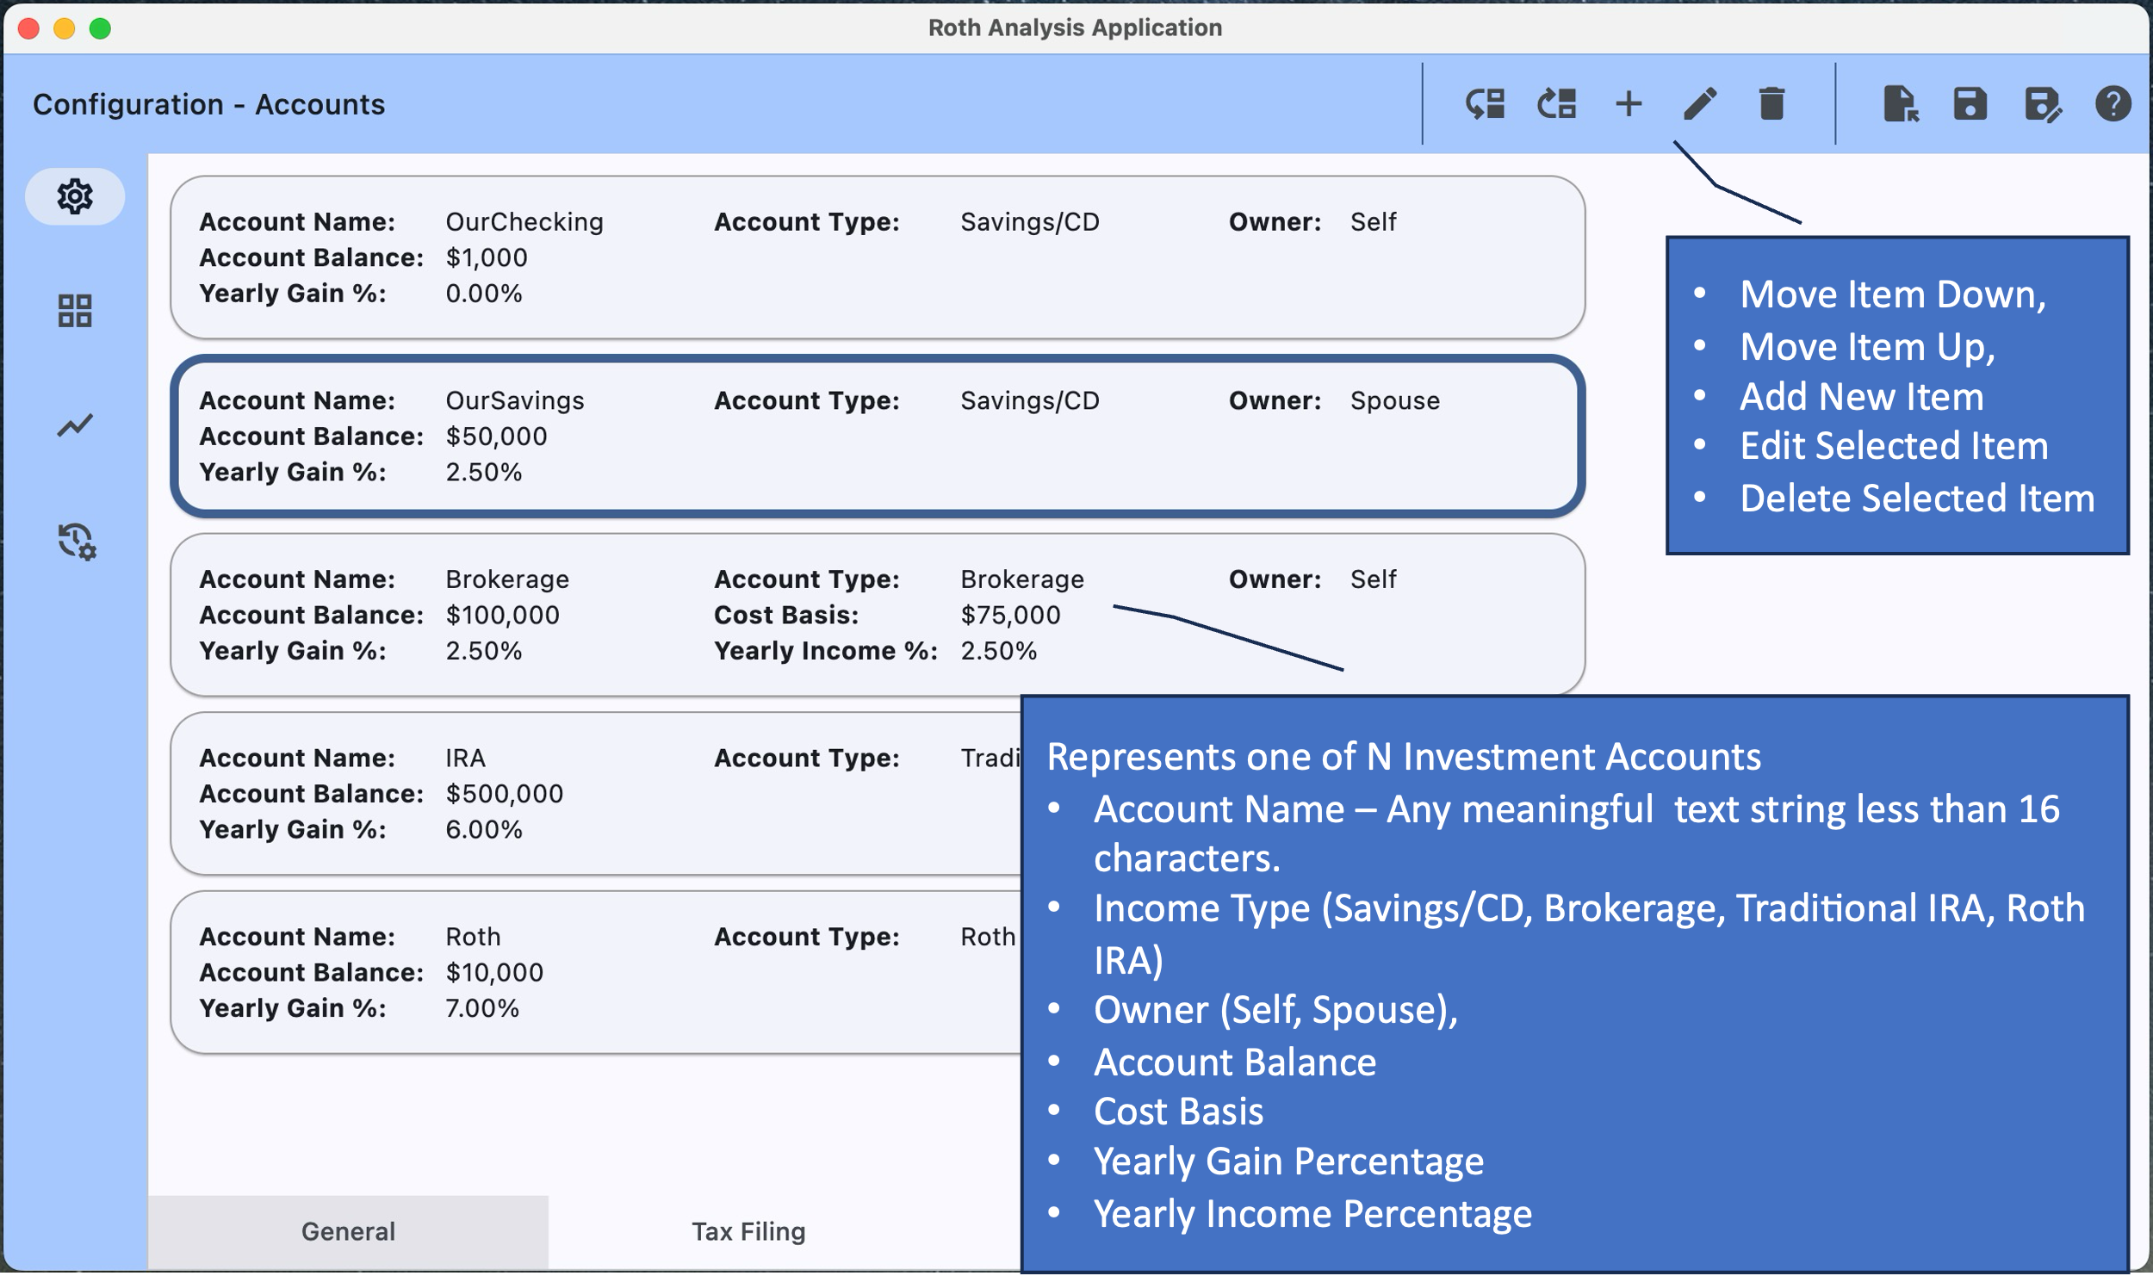

Displays and allows modification to all of the investment accounts in the plan. Existing items can be moved up, moved down, edited or deleted, i.e., via the buttons on the application bar. Note: That an item can also be edited by double-clicking on it which provides the following edit form…

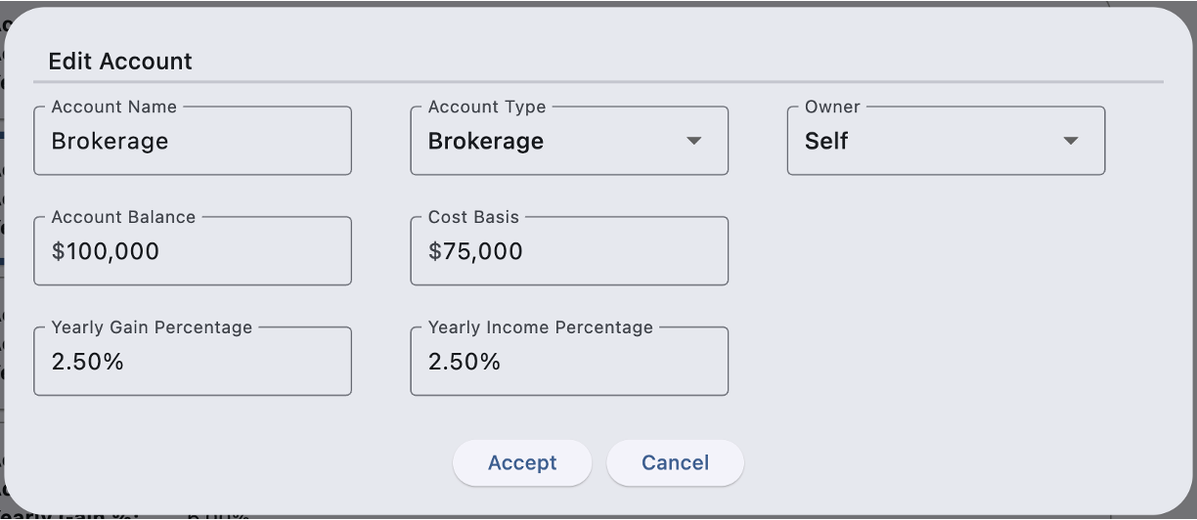

|  |  |
| --- | --- |
| Field Name | Field Description |
| Account Name | Enter a meaningful name for this account. Currently must be 15 characters or less. |
| Account Type | Select one of:   * “Savings/CD” * “Brokerage” * “Traditional IRA” * “Roth IRA”. |
| Owner | Select one of: “Self” or “Spouse. |
| Account Balance | Account balance at the start of the plan. |
| Cost Basis | The amount of the balance that represents the cost basis. Only valid for accounts of type “Brokerage”. If unsure, enter the same value as on Account Balance. |
| Yearly Gain Percentage | The yearly increase in account value due to price gains. |
| Yearly Income Percentage | The yearly increase in account value due to interest and dividends. Only valid for accounts of type “Brokerage”. If unsure, enter 0% and use Yearly Price Gains as a Total Gain amount. |

Notes:

* The rationale for the additional modeling in accounts of type “Brokerage”, i.e., “Cost Basis” and “Yearly Income Percentage” is to allow for improved federal tax accuracy with respect to handling of capital gains when assets must be removed from the brokerage account.
* Should there be more than on account of a particular account type, the analysis algorithm chooses them in the order found in the list of account types. Though exceptions exist.
* For the analysis to operate there are some investment account requirements.

1. There must be at least one Savings/CD account that gets used in the analysis as a form of checking account.
2. There must be at least one Traditional IRA account, i.e., to convert from.
3. There must be at least one Roth IRA account, i.e., to convert into.

### Configuration - Scenarios

### 

Displays and allows modification to all of the investment accounts in the plan. Existing items can be moved up, moved down, edited or deleted, i.e., via the buttons on the application bar. Note: That an item can also be edited by double-clicking on it which provides the following edit form…

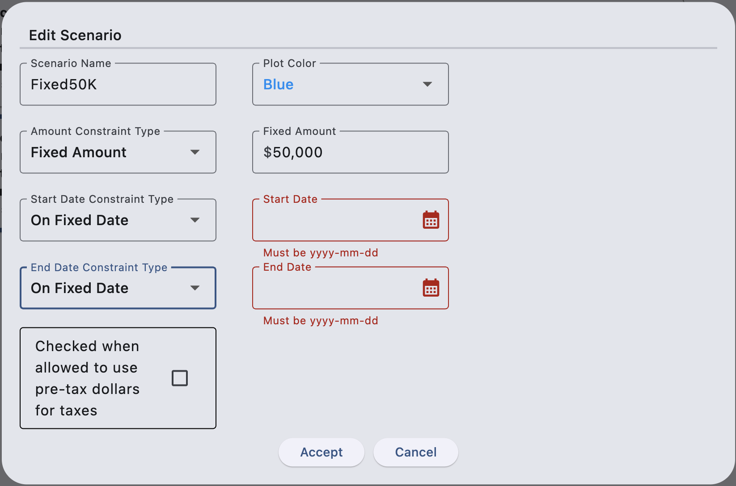

|  |  |
| --- | --- |
| Field Name | Field Description |
| Scenario Name | Enter a meaningful name for this scenario. Currently must be 15 characters or less. |
| Plot Color | Select from one of five possible colors. The chosen color will be used to represent the scenario in the Graphical result, i.e., to visually separate it from the other scenarios. |
| Amount Constraint Type | Select one of:   * “Fixed Amount” – Identifies a fixed Roth Conversion dollar amount to perform for the timeframe the scenario is valid for. * “MAGI Limited” – Identifies a MAGI limit that must not be exceeded. The analysis increases or decreases the yearly Roth Conversion amount to be close to, but less than, the MAGI limit. The user for example can choose a MAG limit that ensures they stay within a certain tax bracket. Note: This value is increased yearly based on the configured cost-of-living. |
| Start Date Constraint Type | Select one of:   * “On Start of Plan” * “On Fixed Date”.   Note: When “On Fixed Date” is chosen, the tool will also allow specification of the start date. |
| End Date Constraint Type | Select one of:   * “When RMDs begin” * “On Fixed Date” * “On Start of Plan”   Note: When “On Fixed Date” is chosen the tool will also allow specification of the end date. |
| Allow Use of Pre-Tax Dollars for Taxes | Accepted financial advice is that pre-tax dollars should not be used to pay taxes on Roth Conversions. Thus, the algorithms reduce or even eliminate a yearly Roth conversion if there are insufficient taxable assets to pay the taxes. Checking this option ignores this and allows additional Taxable IRA assets to be used to pay resulting taxes. |

Notes:

* For the analysis to operate, there must be at least one Roth Conversion Scenario.

### Configuration - Errors

If an attempt is made to exit configuration and errors exist in the configuration dialog similar to the following is shown…

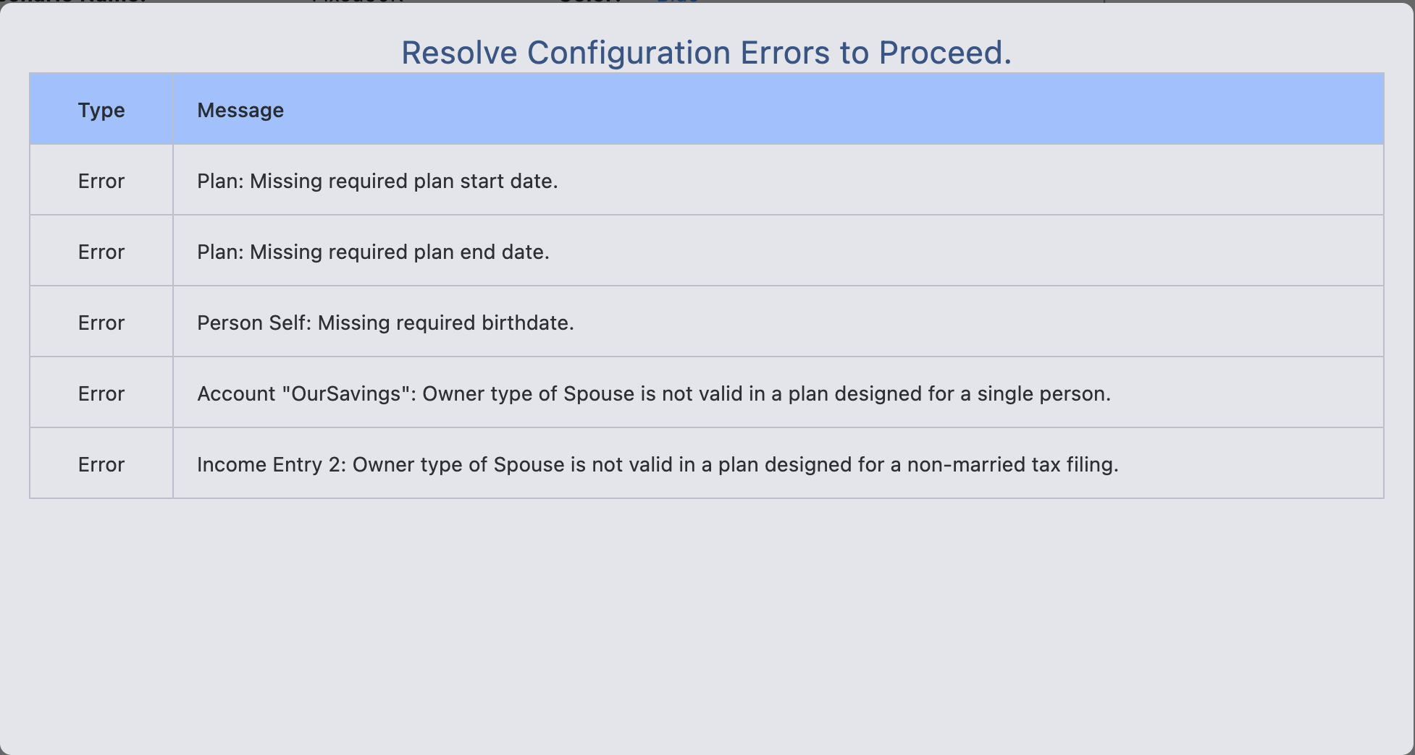

Note: All errors must be resolved before the analysis algorithms will run.

## Results

### Results - Graphical

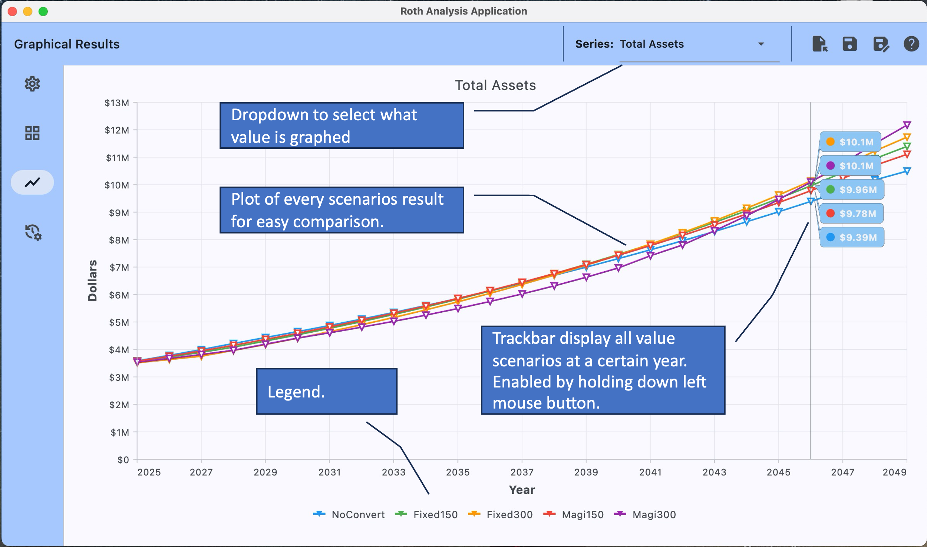

The graphical results view plots s single variable/ result for all configured scenarios over the timeframe specified in the overall plan. The legend shows the scenarios in the plot using the user’s configured scenario name and scenario color. The example above is plotting estimated “Total Assets” (across all accounts) for five different scenarios.

|  |  |  |
| --- | --- | --- |
| Number | Scenario Name | Description |
|  | NoConvert | Configured with no Roth Conversions. |
|  | Fixed150 | Configured to make $150,000 Roth Conversions from the start or the plan until RMDs start. |
|  | Fixed300 | Configured to make $300,000 Roth Conversions from the start or the plan until RMDs start. |
|  | Magi150 | Configured to make enough Roth Conversions to get close to a $150,000 federal modified adjusted gross income from the start or the plan until the plan ends. |
|  | Magi300 | Configured to make enough Roth Conversions to get close to $300,000 federal modified adjusted gross income from the start or the plan until the plan ends. |

Several different results can be plotted as shown below.

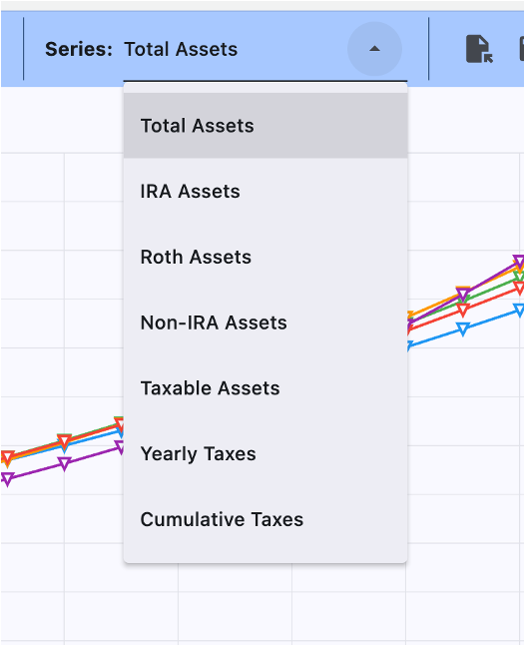

|  |  |
| --- | --- |
| Series Name | Field Description |
| Total Assets | This series plots the sum of ALL of the account balances (regardless of account type) over all of the years in the plan. |
| IRA Assets | This series plots the sum of ALL of the Traditional IRA account balances over all of the years in the plan. |
| Roth Assets | This series plots the sum of ALL of the Roth IRA account balances over all of the years in the plan. |
| Non-IRA Assets | This series plots the sum of ALL of the account balances (except the Traditional IRA) over all of the years in the plan. That’s is, all of the “Savings/CD”, “Brokerage”, and “Roth IRA” accounts. |
| Taxable Assets | This series plots the sum of ALL of the taxable account balances (over all of the years in the plan. That’s is, all of the “Savings/CD” and “Brokerage” accounts. |
| Yearly Taxes | This series plots the sum of ALL of the taxes accrued in a given year. That’s is, all of the Federal Income Taxes, State Income Taxes, Local Income Taxes, FICA Income Taxes, Medicare Income Taxes, and IRMAA Taxes. |
| Cumulative Taxes | This series plots the year over year accumulation of the yearly taxes accrued up to that point for a given year. |

### Results - Tabular

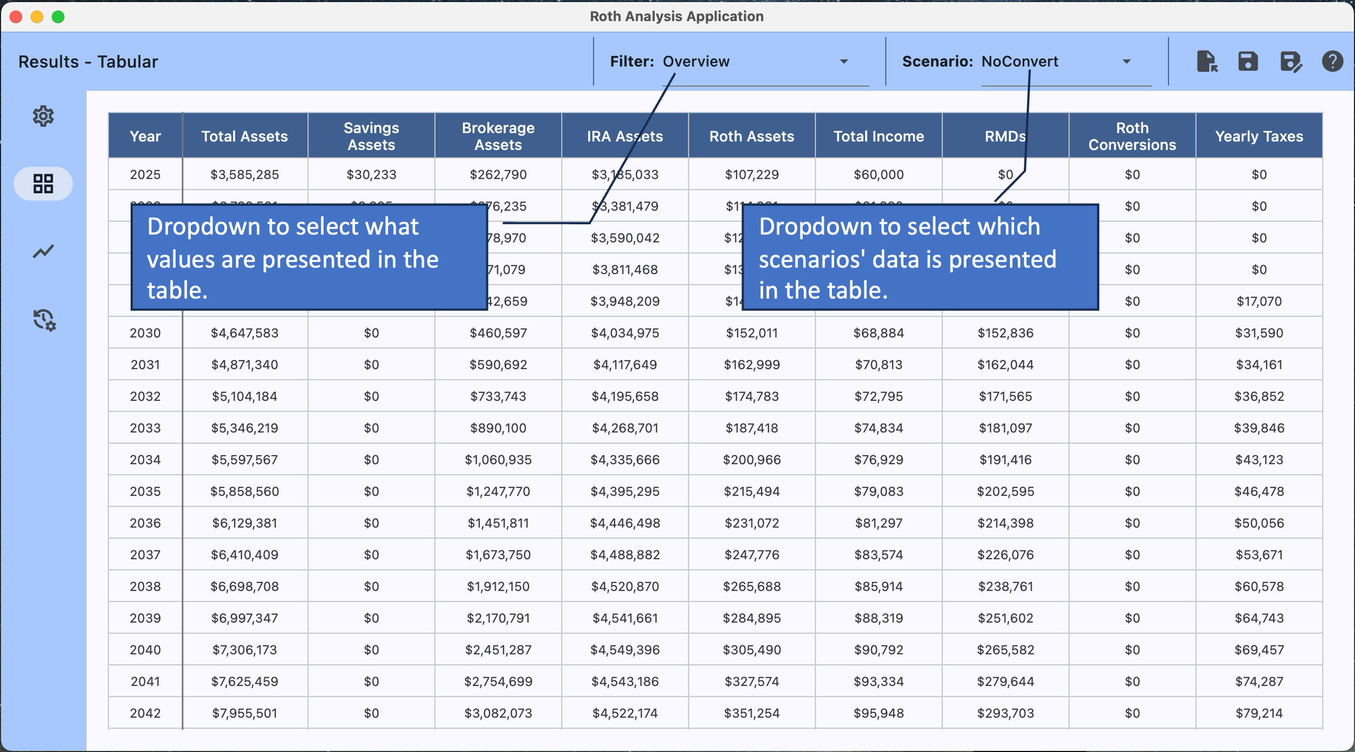

The tabular results view provides year-by-year values, one per year for each of the actionable years in the plan. Several different filters are provided where each filtered view provides for different yearly values.

#### Filter Options

|  |  |
| --- | --- |
| Filter Name | Column Description |
| Overview | Each row represents a specific year and provides a year-by-year report of a number of different values related to that year. For a description of the values presented see Table Columns for Results - Tabular [Overview] below. |
| Tax Details | Each row represents a specific year and provides a year-by-year report on the various taxes related to that year. For a description of the values presented see Table Columns for Results - Tabular [Tax Details] |
| Account Details | Each row represents a specific year and each column (one per configured account) provides a year-by-year report on the account balance for that year. |

#### Table Columns for Results - Tabular [Overview]

|  |  |
| --- | --- |
| Column Name | Coulmn Description |
| Year | The year represented by this row. Generally, year will run from the configured plan start date through the configured plan end date. However, should the plan not be feasible because there are insufficient funds to reach the plan end date, the table will only cover up to and including the year where all assets were exhausted. |
| Total Assets | The total available assets at the end of that year. |
| Savings Assets | The total available assets in accounts of type “Savings/CD” at the end of that year. |
| Brokerage Assets | The total available assets in accounts of type “Brokerage”. at the end of that year. |
| IRA Assets | The total available assets in accounts of type ““Traditional IRA” at the end of that year. |
| Roth Assets | The total available assets in accounts of type “Roth IRA” at the end of that year. |
| Total Income | The total income earned for that year. |
| RMDs | The amount of Required Minimum Distributions that were taken that year. |
| Roth Conversions | The amount of Roth Conversions that were performed that year. |
| Yearly Taxes | The amount of taxes (Federal Income Taxes, State Income Taxes, Local Income Taxes, FICA Income Taxes, Medicare Income Taxes, and IRMAA Taxes) paid in that year. |

#### Table Columns for Results - Tabular [Tax Details]

|  |  |
| --- | --- |
| Column Name | Coulmn Description |
| Year | The year represented by this row. Generally, year will run from the configured plan start date through the configured plan end date. However, should the plan not be feasible because there are insufficient funds to reach the plan end date, the table will only cover up to and including the year where all assets were exhausted. |
| Federal MAGI | The estimated federal modified adjusted gross income for the year.  Note: For scenarios that use the MAGI limit option, users should be aware that the algorithm insures (a) that the MAGI is below that limit and (b) that it within a percent of the configured limit. Do NOT expect it to be exactly at the configured limit. |
| Cumulative Taxes | The year over year accumulation of the yearly taxes paid up to that year. |
| Total Taxes | The sum of ALL of the taxes paid for that year. That is, all of the Federal Income Taxes, State Income Taxes, Local Income Taxes, FICA Income Taxes, Medicare Income Taxes, and IRMAA Taxes. |
| Federal Taxes | The federal income taxes paid in that year. |
| State Taxes | The state income taxes paid in that year. |
| Local Taxes | The local income taxes paid in that year. |
| FICA Taxes | The FICA income taxes paid in that year. |
| Medicare Taxes | The Medicare income taxes paid in that year. |
| IRMAA Taxes | The taxes related to an Income-Related Monthly Adjustment Amount that can be charged when your MAGI two years back reaches beyond a certain limit.  Note: The program currently has no way to know what the users MAGI was for the two years prior to the plan start. Therefore, the IRMAA for the first two years of the plan is always $0.00 |

### Results - Transaction Log

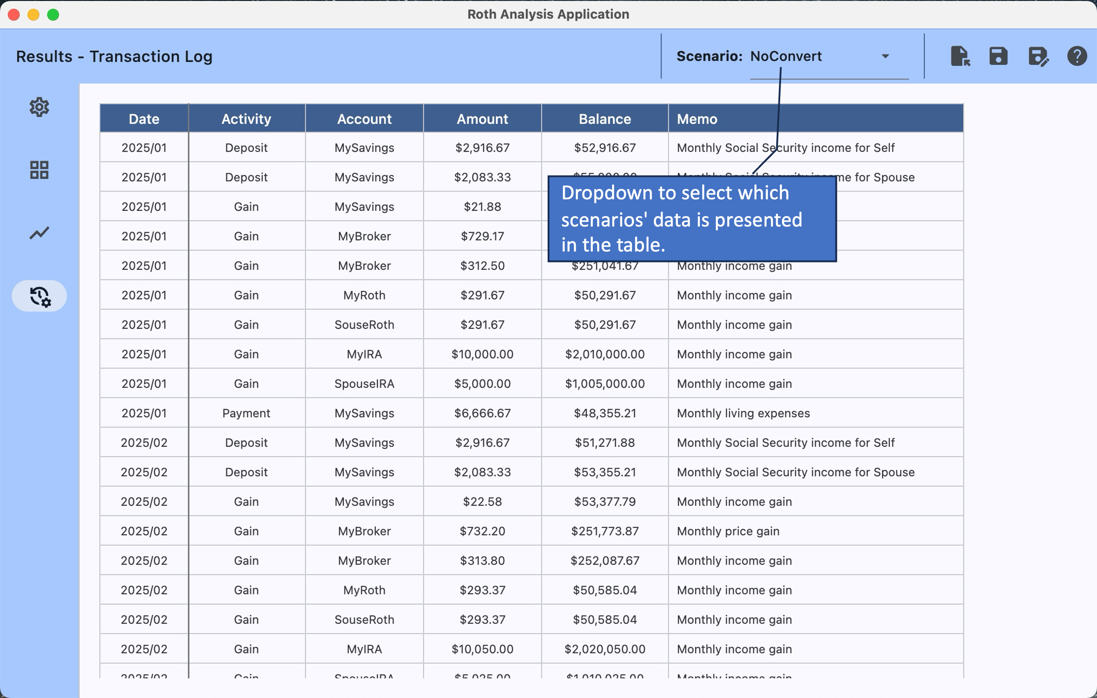

The applications algorithm operates by simulating year-by-year and month-by-month transactions. This view provides a view of all of the simulated transactions as well as some year-end summary information.

#### Table Columns for Results - Transaction Log

|  |  |
| --- | --- |
| Column Name | Coulmn Description |
| Year/Month | The year and month (yyyy/mm) of the transaction represented this row |
| Activity | Activity or transaction type. E.g., “Deposit”, “Withdraw”, “Payment”, “Gain”, “AccountInfo”, “TaxInfo”, or “IncomeInfo” |
| Account | Name of the account that the transaction ocured in. |
| Amount | Dollar amount of the transaction. |
| Balance | Balance in the named account at the completion of the transaction. |
| Memo | Textual explanation of the purpose of the transaction. |

# Scenario Analysis Algorithmic Concepts

The analysis of any particular scenario is performed by running a simulation for each month of each year of the actionable plan.

#### Reserved Accounts

The analysis designates one or more of the user’s accounts for one of two purposes.

1. Cash-Account – Consider this a form of checking account; assets are moved into this account to cover expenses and out of this account to pay expenses. It is chosen based on it being the first savings account in the list that also happens to have the lowest yearly gains.
2. Long-Term-Savings-Account – The account that excess RMDs are deposited into. It is chosen based on it being the first taxable account that also happens to have the highest yearly gains.

#### Yearly Initialization

At the start of a year.

1. Investment account information is initialized form the previous year, or in the case of the first year of the plan, from the configuration data.
2. A monthly income plan is created for all configured income streams (adjusted for the year of the plan).
3. A monthly payment plan is created for invariant taxes, i.e., FICA, Medicare, IRMAA.
4. Roth Conversion constraints are calculated.
5. At this poit month-by-month simulation occurs for that year.

#### Month-by-Month Simulation

For each month of each year.

1. Plan is initialized / adjusted to ensure that execution of the ROTH conversion plan is viable, i.e...
   1. It will not result in the conversion scenario’s MAGI constraint being exceeded (should one have been configured).
   2. It will not result in an overdraft of the IRA accounts, i.e., sufficient IRA funds must exist to perform the conversion.
   3. It will be able to be executed within the available income and account assets, i.e., pay required taxes (which are re-estimated here as well).
   4. If any of the constraints above is violated the Roth Conversion amount will be adjusted until it is actionable.
2. Monthly income (from all income stream) is added to the Cash-Account.
3. Monthly FICA taxes are pai from the Cash-Account.
4. Monthly Medicare taxes are paid the Cash-Account.
5. Interest and Dividends are accrued to all accounts.
6. The month’s total expenses including all income taxes and IRMAA taxes is calculated / estimated.
7. The amount of these expenses that can be covered by assets in the Cash-Account is determined and conversely how much must be covered by other assets. Called the ExpenseBalanceBeforeRMDs.
8. Move monthly RMDs (if any) to …
   1. The Cash-Account up to ExpenseBalanceBeforeRMDs and further, calculating ExpenseBalanceAfterRMDs.
   2. The balance of the RMDs (if any) to the Long-Term-Savings-Account.
9. Move up to ExpenseBalanceAfterRMDs from any other accounts to the Cash-Account.
10. Pay IRMAA taxes from the Cash-Account.
11. Move/Convert monthly Roth Conversion Amount from available IRA accounts; depositing them into the appropriate Roth accounts (user account or spouse account as appropriate). If for some reason the full planned amount cannot be moved / converted, update the monthly conversion plan.
12. Pay monthly Federal Income tax from Cash-Account.
13. Pay monthly State Income tax from Cash-Account.
14. Pay monthly Local Income tax from Cash-Account.
15. Pay monthly living expenses from Cash-Account.
16. If in any step it is determined that insufficient funds exist, the yearly analysis for the scenario is terminated.